Machine Learning for Customer Churn Prediction in E-Commerce: Improving Retention Strategies with Predictive Analytics
1. Introduction
E-commerce faces many difficulties related to customer loyalty. This is due to low switching costs and a high level of competition in this area. According to Reichheld (2001), acquiring a new customer costs approximately five times more than keeping the existing one. Most e-commerce companies measure churn once it has already happened and act reactively afterwards. While e-commerce generates a large amount of behavioural and transactional data on a daily basis, the majority of this data is being used for reporting rather than predictive purposes; therefore, there is a gap that can be filled by prediction tools. This project presents the development of a prediction tool that will allow to identify customers who may leave before they actually do. Even a small reduction in churn can be very beneficial in terms of profitability (Reichheld & Sasser, 1990).
2. Problem Definition
The majority of online retailers wait until after customers have departed to respond to churn, resulting in retention efforts being limited to damage control activity. By the time a recovery email or a discount message is sent out, most of the time the consumer has already left for a competitor. The main issue here is timing; companies find out that churn has happened but are unaware of it beforehand.
According to Matuszelański and Kopczewska (2022), the signs of churn can be identified in advance through the analysis of customer data. By observing the reduction in the number of customer visits, smaller size of the shopping cart, or the increase in the time between purchases.
Thanks to predictive modelling it is possible to behave on the basis of those signs before churn actually takes place. A model built on the basis of the behavioral data of past churned customers would be able to identify current customers with the same behavioral patterns as before.
3. Aim and Objectives
Aim: To create and verify a predictive system that can anticipate which customers in e-commerce are likely to leave so that identify customers at risk of churn early and support timely retention decisions.
Hypothesis: Accurate predictions of churn based on consumers’ transactions and engagement can lead to cost-effective marketing actions.
Objectives
1. To analyze previous studies that focused on the prediction of customer churn and its retention analytics.
2. To gather data from suitable e-commerce transaction datasets and clean it to do exploratory data analysis
3. To create and compare several prediction models and select the best one by using some metrics such as accuracy, precision, recall, F1-score, and AUC-ROC.
4. To come up with an interactive dashboard for stakeholders to provide them with clarity on the results and reasons for churn.
5. To explain and provide suggestions for the managers on how to retain the customers using the results.
4. Scope
The project aims to create and test a predictive churn model based on historical data from e-commerce transactions, and display the results using an interactive dashboard. No live execution of the model or CRM implementation will be undertaken, as that is not a part of the academic project within two semesters. The study is solely based on publicly available data; hence, there will be no need to gather primary data. The focus is limited intentionally in order to make sure that thorough analysis can be provided within two semesters without extending into the areas outside the given timeframe.
5. Methodology
The project will utilize the CRISP-DM methodology (Chapman et al., 2000), which consists of the following steps: understanding the business, understanding the data, preparing the data, modeling, evaluation, and deployment (the latter refers to using a dashboard rather than a live system). Modeling will begin with logistic regression as a transparent baseline and continue with Random Forest and XGBoost, as various ensemble methods have been shown to be more effective than simpler classifiers in predicting customer churn (Lemmens and Croux, 2006). The performance of the created models will be evaluated according to different measures such as accuracy, precision, recall, F1-score, and AUC-ROC instead of using only one measure. Python will be used for data processing and machine learning model development, while Power BI will be used to present the results in an interactive dashboard. GitHub will be used for version control and project code management.

Figure 1: Architecture Plan
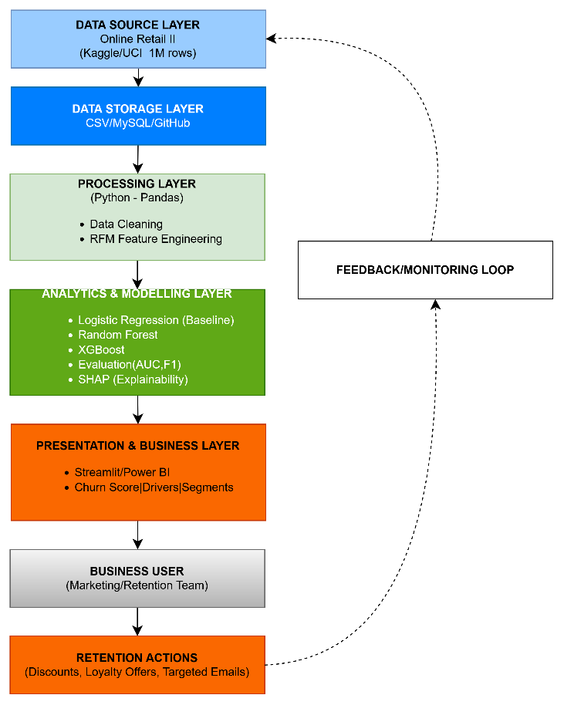
DATA SOURCE LAYER
Online Retail|| (UCI 1M rows)

The architecture has five components – Data Source, Storage, Processing, Modelling, and Presentation. The data for Online Retail II is stored in Excel format (.xlsx) and processed using Python to clean the data and calculate customer-level RFM features. Several models will be created and validated in the system. Data generated by the models is sent to a Power BI dashboard for the business stakeholders to assess retention strategies.
6. Data Sources
The main data used in this research is the Online Retail II dataset obtained from the UCI Machine Learning Repository. This dataset includes about a million records of transactions conducted by an online retailer in the UK from the period of 2009 to 2011. This dataset is available for academic purposes and does not contain any identifiable information.
7. Expected Deliverables
The objectives expected to be achieved at the conclusion of Semester 2 include: (1) delivery of a dataset after cleaning and feature engineering; (2) training of a predictive model along with its performance metrics; (3) creation of an interactive dashboard to present churn risk and the key drivers; (4) production of a report highlighting business suggestions; (5) the development of a code repository.
8. Project Timeline
Table 1: Project Timeline
Phase | Sem 1 Wks 1–4 | Sem 1 Wks 5–8 | Sem 1 Wks 9–12 | Sem 2 Wks 1–4 | Sem 2 Wks 5–8 | Sem 2 Wks 9–11 | Sem 2 Wks 12–14
Literature review & problem scoping
Data collection & cleaning
Exploratory data analysis
Feature engineering & baseline model
Model tuning & comparison
Dashboard development
Final evaluation & write-up
9. Ethical and Legal Consideration
The data will be made public after being rendered anonymous, thus presenting a minimum privacy risk. However, the principles of data minimization and limitation of purpose, as dictated under the GDPR, will be followed (ICO, 2018). No attempts will be made to re-identify individuals, and all information will be kept in secure systems. The model will also undergo testing to assess possible bias in recognition of people; for example, the possibility of systematically recognizing certain people from particular groups as being higher risk than other categories of customers. All involved data sources are subject to licenses for academic purposes, and the ethics form will be submitted to confirm that there was no collection of primary data from human subjects.

References
Chapman, P. et al. (2000) CRISP-DM 1.0: Step-by-step data mining guide. Chicago: SPSS Inc.
ICO (2018) Guide to the General Data Protection Regulation (GDPR). Wilmslow: Information Commissioner's Office.
Lemmens, A. and Croux, C. (2006) 'Bagging and boosting classification trees to predict churn', Journal of Marketing Research, 43(2), pp. 276–286.
Matuszelański, K. and Kopczewska, K. (2022) 'Customer churn in retail e-commerce business: Spatial and machine learning approach', Journal of Theoretical and Applied Electronic Commerce Research, 17(1), pp. 165–198.
Reichheld, F.F. (2001) Loyalty Rules! How Today's Leaders Build Lasting Relationships. Boston: Harvard Business School Press.
Reichheld, F.F. and Sasser, W.E. Jr. (1990) 'Zero defections: Quality comes to services', Harvard Business Review, 68(5), pp. 105–111.
Chen, D. (2012). Online Retail II [Dataset]. UCI Machine Learning Repository. https://doi.org/10.24432/C5CG6D.

AI Use Declaration
AI technologies were employed for structuring and writing (delegation) within the context of specifications provided in the assessment (description). The outputs produced by AI techniques were evaluated against the course's learning goals and improved accordingly. I prepared the final document and its final recommendations independently and bear entire responsibility for the correctness of the presented information (discernment).

